# SOUND RECORDER

# ANDROID APPLICATION



Submitted in partial fulfillment of the requirements for the award of degree of

## COMPUTER SCIENCE AND ENGINEERING

**To**

**UNIVERSITY INSTITUTE OF ENGINEERING CHANDIGARH UNIVERSITY, GHARUAN**

**January 2021**

**SUBMITTEDBY:- SUBMITTEDTO:-**

Tarush Kaistha–18BCS2068 ER. Charnpreet Maam

## PROJECT DESIGN

Sound Recorder is an android based application that usually records the voice of the users through a media recorder and then plays them through a media player.

So, when users run this app, at first the main UI would be including an image which describes the audio as an art of living surrounded by black background which is basically an AppCompat theme that is applied to the whole application.

So, it’s encapsulated under a relative layout followed by image views, image buttons. One of them is a mic through which the users would record their audio & next one is the list icon that would show us the list if audios recorded so far along with time and date constraints.

There is a recycler view which contains all the audios in the form of a list. On clicking any of the audio, the audio would start playing through the media player.

One unique feature of this app is that the audios which are being recorded are saved to phone internal storage so the users could listen to their audio by searching in their phone internal storage.

DFD for Sound Recorder:

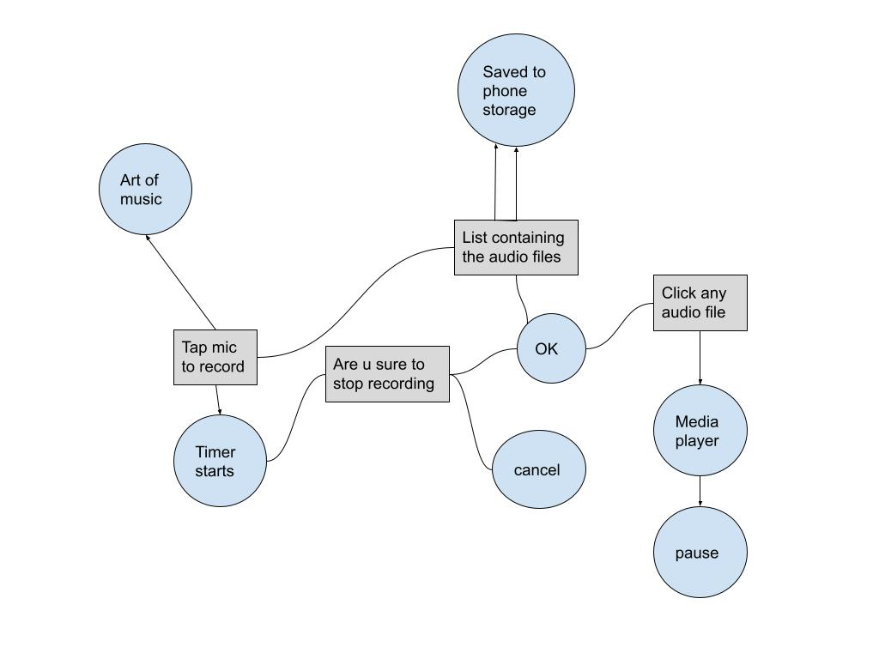

**METHODOLOGY**/ **PLANNING OF WORK**

We have divided our project into different modules under strict discipline & maintained a decorum for partial achievement of the project.

* Firstly, I had installed the Android Studio IDE environment for coding in Java.
* Then, I made the prototype of the app including it’s UI, appearance, performance.
* Outlined various components such as Chronometer, Media Player, Media Recorder, various layouts and views such as Image View, Relative Layout and RecyclerView which would complete the app.

In the above manner, my app is built.

## INNOVATIONS IN PROJECT

In this project, I have not included any database, privacy, security including authentication and authorization using google. Also, if the users want to share the audio with one another, then also they can’t share.

These features would be added as soon as possible.

# Implementation

The following screenshots depict the implementation of my project.

A.

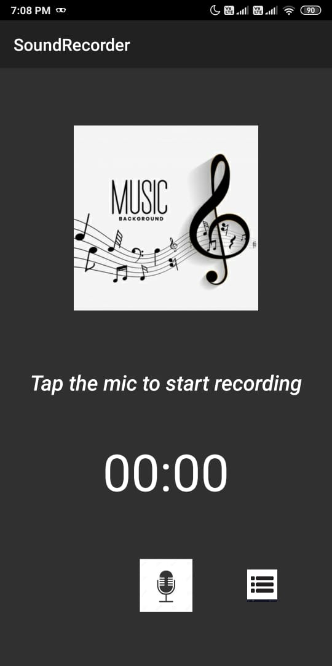

When the user opens the app, this is the main UI. There is a chronometer which starts counting of the audio as soon as the users click the mic.

B.

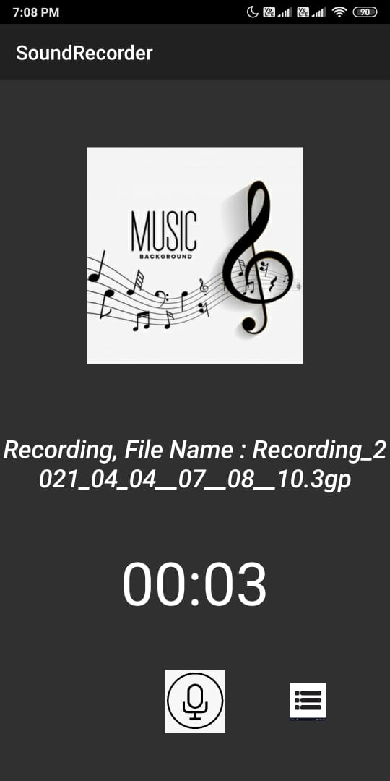

Here, when the users click the mic, the recording starts and the file is saved in gp format which is more flexible than mp3 format.

C.

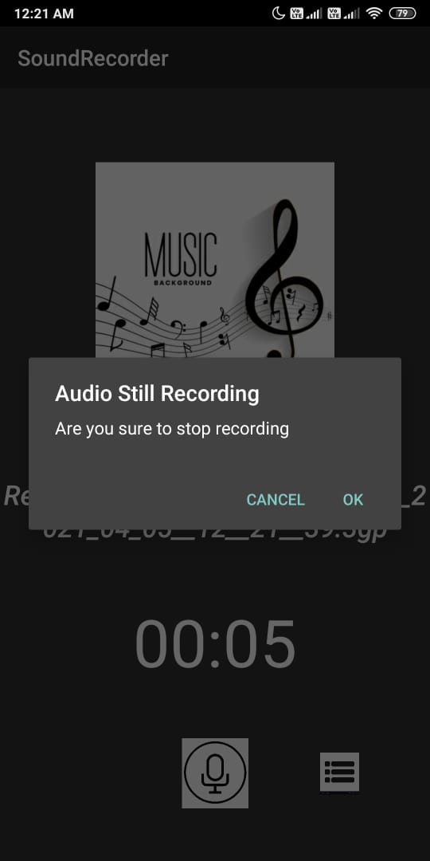

Here, if the user clicks on the list button then he would be alerted through the alert dialog box floating on the screen that would indicate whether the user wants to stop the recording or not.

D.

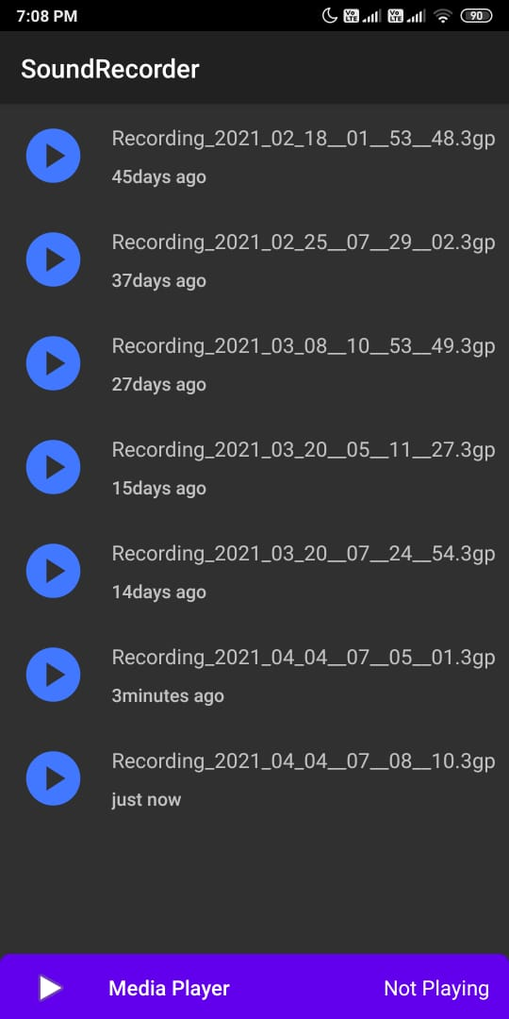

As soon as users click the list button, they would be redirected to another screen which would containing the list of audios shown through recycler view.